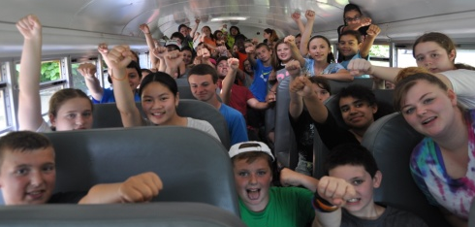
Middle School
Summer Camp 2019

Who: Students going into 6-8th grade
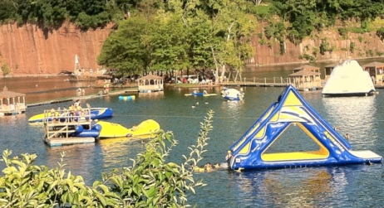
When: July 8-12 (see details and times below)
Where: The Huntington Chapel: 177 Ripton Rd. Shelton.
We meet here daily and go out on a bus
What: Monday: Field games: 9am-noon
Tuesday: Short Beach in Stratford: 9am-2pm.
Wednesday: Mini-golf at Olde Sawmill in Oxford: 9am-12:30pm
Thursday: Brownstone Exploration and Discovery Park: 9am-5pm
Friday: Field games at Wolfe Park: 9am-noon
*Friday Night Family Picnic: Join us at 6:30pm for a potluck dinner, with songs, and activities for
all ages
Cost: Paid before June 2nd: Early Bird: $65 ($35 w/out Brownstone)/June 2nd-June 30: $70 ($40 w/out Brownstone)/ At door price: $80 ($45 w/out Brownstone)
Please make payment through paypal online or you can make checks out to:
“the Huntington Chapel” with a memo saying “Middle School VBS.” (Please drop off or mail the money to: The Huntington Chapel, 177 Ripton Rd. Shelton, CT. 06484.) You may bring extra money for food and snacks any day that we go out.
Contact: the church with any questions: (203)929-1222
Person in Charge: Jason Mayo (203)448-8785 or jmhercules85@gmail.com
For extra copies of this form go to: www.thehuntingtonchapel.com and follow the links through the VBS tab

Note: On Tuesday, and Thursday, we will be getting back to the church later than the regular VBS hours. Please make a note of the time, and have your child bring a lunch or money to buy a lunch for Tuesday, and a bag lunch for Thursday.

Other Summer Events: Also join us throughout the summer for other great events including: Water Wars Jul 26/Messy Games Aug 9/Carnival Games Aug 23 All from 6:30-8pm on Fridays. We will also have a community potluck picnic Sep. 8th after the church service starting at 12 noon. We hope that you can come!

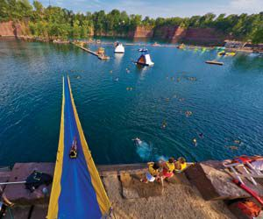
Registration Checklist:
1: Form: Fill out the online registration/medical release form
2: Payment: Make payment through the Paypal tab online or send in a check
